# Abstract

Keywords:

# Introduction

Ankle-Foot Orthosis (AFO) orthotics are widely used in cases of "drooping foot" caused by fibular nerve neuropathy. The conventional manufacturing of an AFO consists of manual molding in gypsum, followed by the thermoplastic material (thermoforming) modeling and subsequent cutting in the AFO final format, which requires a great deal of effort and skill from the operator. In addition, the entire manufacturing process should be repeated if AFO is destroyed or patient conditions change for some reason.

Additive Manufacturing (MA), also known as 3D printing, has been widely used in the health area and its use has grown more and more. 3D printers can easily produce modifiable objects without any fixed template, which makes them unique. Examples of applications in health are the printing of artificial organs using bioprinters [1,2], titanium devices for skull defects [3], hip prostheses [4,5] and hands for amputations [6,7] . MA makes it possible for physicians and surgeons to create customized patient products [8]. Recently, several tests for the manufacture of orthoses using MA have been made [9,11].

The manufacture of orthoses by MA has great advantages over the conventional thermoforming process, requiring less need for effort and manual skills, besides making the parts much easier to reproduce. Once the 3D model is archived, production can be easily repeated. It is important to note that, to be used in real applications, devices manufactured by MA must have properties similar to parts that will be replaced and similar to parts normally produced by conventional processes (injection molding, thermoforming, etc.) [121], [ 9].

There are different processes of MA and among the processes most used in the manufacture of health products is Selective Laser Sintering (SLS). SLS uses the powder material, can be printed, polymers, metals and even ceramics. However, SLS may be a bit more time-consuming, in addition to having to be supplied with a larger amount of material.

In the case of orthotics, factors such as functionality, weight, aesthetics, durability and comfort are very important, so these should be taken into account when choosing the MA material and process. Among the various types of materials available, polymers and composites are best suited for orthotics, and polyamide (PA) is one of the polymeric materials that can be used and generally meets all the characteristics required for application in an AFO, for example.

The anisotropy of the material is the biggest problem when it comes to parts and components manufactured by MA. For SLS, many print parameters should affect the density and mechanical properties of printed parts, such as energy density, laser power, scanning space, laser beam speed, and component orientation ([139], [140] ], [141], [55]). In addition, the layer thickness, cooling rate and temperature of the powder bed on the printing platform also influence the mechanical properties of the components manufactured by SLS [143]. The use of virgin or reused powder also has an effect on mechanical properties ([144], [145], [146]). It should also be taken into account that the mechanical properties of components manufactured by MA can be affected by the properties of the material before printing, especially in the case of SLS, in which the uniformity of the raw material, microstructural evolution and the ability of the printer to form parts without causing the thermal degradation of the powder directly influence the mechanical properties [142].

Unique aspects of these technologies, such as the layered manufacturing process and the relative lack of clinical history of health products obtained by MA, establish challenges for determining the characterization and evaluation methods of the finished device, as well as the validation processes and acceptance criteria for these finished devices. In this way, specific technical standards have been developed to evaluate the integrity of printed parts, such as ASTM F3091M-14 and ASTM F3122-14. Based on the methods described in these standards, the present work aims to evaluate the effects of the SLS manufacturing processes and the construction directions on the mechanical strength of the PA, in order to guarantee and optimize the performance and safety of this material when used in AFOs manufactured by MA.

# 2.0. Materials and Methods

# In this section, the materials, equipment and conditions used in the production and mechanical characterization of the samples is described in detail.

# 2.1. Materials

# The material used in this study was polyamide (DuraForm® PA Plastic). It was used 40% recycled material. Differential Scanning Calorimetric analysis showed almost none thermal variation using 40% of recycled material.

# 2.2. Printing parameters

# The material was processed at 13 watts laser power, 5 m/s scan speed, and power layer thickness of 0.1 mm.

# 2.3. Experimental plan

ASTM F3091 / F3091M-14 specifies orientations and locations of SPs on the building platform for evaluation of mechanical properties. Classes I and II reported in this standard describe coordinate system and testing requirements for compliance and quality of additive manufacturing. The criterias of class I are more rigorous and, in this way, they are applied for the production of pieces of high quality and high degree of confidence. This class states that they must be fabricated and tested SPs in the XY or YX and ZX or ZY directions. In order to achieve a more rigorous approach than Class I, in the present study we used a more conservative work plan, manufacturing and testing SPs in all directions as established by the ASTM Standard 52921-13 - Standard Terminology for Additive Manufacturing- Coordinate Systems and Test Methodologies, which establishes requirements for validation of the printing process.

Thus, we have printed 5 SPs in each of the directions/orientations of the building platform: XYZ, XZY, YXZ, YZX, ZXY, ZYX, as shown in Figure 2. In Figure 3 we can see the directions plan on the building platform of AMR SLS printer.

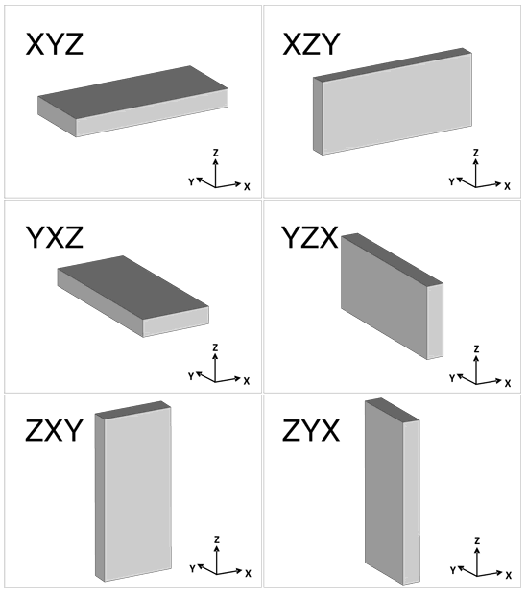

Figure 2. 3D printing direction according to ASTM 52921.

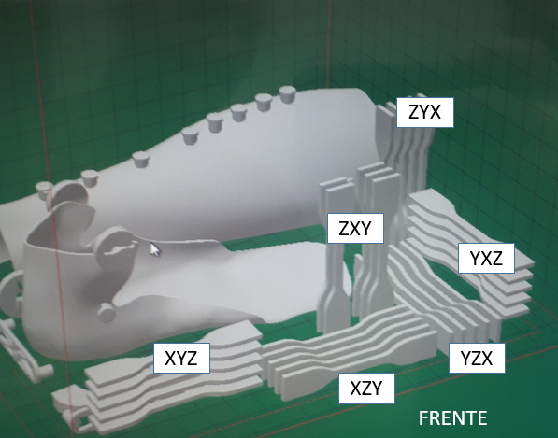

Figure 3.SPs manufacturing orientation on the building platform of the SLS printer.

The dimensional evaluation of the SPs was performed in the dimensions wc (width) shown in Figure 1 and in the cross section (thickness) using a digital caliper. Measurements were made at 3 points in each SP, both in width and thickness. The error, in absolute or relative format, must be within ± 0.1 mm in accordance with the specifications of ASTM F3091 / F3091M-14.

2.4. Tensile Testing

The tensile test was performed at the Materials and Products Testing Division - DIEMP of the National Institute of Technology - INT. The machine used in the test was the universal INSTRON 3382, with a capacity of 100 kN. The machine's device is controlled by Bluehill® software. The displacement rate was 5 mm / min for 3D printed PA. The dimensions were set for each SP. To measure the deformation of the SP was used an attachment extensometer (clip gage) of the own Instron. The properties to be estimated are: Maximum tension (tensile strength), Tension or flow limit (0.2%), Elastic Modulus.

#### 2.2.1. Estimation of the measurement uncertainties in Ultimate Tensile Strength

It was used the Guide to the expression of uncertainty in measurement (GUM) to express the uncertainty of measurement result [5]. The measurement uncertainty was obtained considering Type A standard uncertainty and Type B standard uncertainty. Type A standard uncertainty was obtained from standard deviation divided by the square root of the number of SP for each direction, therefore √5. Type B evaluation of standard uncertainty was obtained from the applied load expanded uncertainty, in %, from Instron certificate number 17062701DM divided by k=2 and resolution of calliper, i.e. R = 0,01 mm / √12 = 2,8868 x10-3 mm.

Type A and Type B standard uncertainties were combined () as can be viewed in equation (1), (Gabauer, 2000).

|  |  |
| --- | --- |
|  | (1) |
| Sensitivity coefficients ci associated with the uncertainty on the measurement xi (2) e (3) : | |
|  | (2) |
|  | (3) |

2.2.2. Estimation of the measurement uncertainties in Yield Strength

In order to calculate the measurement uncertainty of the Yield Strain, the same procedure is the same as the ultimate tensile strength. However, the force used for the calculations is the Yield force instead, obtained from the Bluehill® software during the testing.

1. Results
   1. Dimensional

Table 2 shows the obtained results of dimensional evaluation of 3D printed SPs in the different orientations. The SPs dimensional values are in accordance the ASTM F3091/F3091M-14 and ASTM D638 standards.

Table 2. Dimensional evaluation of SPs manufactured in SLS.

|  |  |  |  |  |
| --- | --- | --- | --- | --- |
| Code | Nominal  width (mm) | Measured width and Expanded Uncert. (mm) | Nominal Thickness  (mm) | Measured thickness and Expanded Uncert. (mm) |
| SLS\_XY | 6,00 ± 0,1 | 6,335 ± 0,099 | 3,20 ± 0,1 | 3,415 ± 0,036 |
| SLS\_XZ | 6,00 ± 0,1 | 6,056 ± 0,018 | 3,20 ± 0,1 | 3,34 ± 0,047 |
| SLS\_YX | 6,00 ± 0,1 | 6,22 ± 0,14 | 3,20 ± 0,1 | 3,349 ± 0,036 |
| SLS\_YZ | 6,00 ± 0,1 | 6,318 ± 0,051 | 3,20 ± 0,1 | 3,477 ± 0,083 |
| SLS\_ZX | 6,00 ± 0,1 | 5,975 ± 0,017 | 3,20 ± 0,1 | 3,263 ± 0,016 |
| SLS\_ZY | 6,00 ± 0,1 | 5,901 ± 0,024 | 3,20 ± 0,1 | 3,132 ± 0,018 |

* 1. Tensile testing

Table 5 shows the average values of the tensile testing, in the different orientations manufacture platform plan. The ultimate tensile strength values varied from 39.36 MPa to 42.49 MPa. The measurement uncertainty ranged from 0.79 to 1.1 MPa, indicating a low dispersion of values, which can best be seen in Figure 9. The ultimate tensile strength value found in the literature for PA (nylon 12, Duraform) 3D printed by SLS was 40 MPa, (Starr et al, 2011) ( the direction studied was not informed) similar to the values found in this study and also in accordance with PA, Duraform datasheet used in this work.

Yield strength values were well homogeneous in all studied orientation with values varying from 18.33 ± 0.44 MPa to 20.48 ± 0.46 MPa, with low dispersions. Finally, the elastic modulus varied from 1377 ± 23 MPa to 1557 ± 21, with the highest values found in the ZX and ZY directions.

Table 5. Tensile testing results of PA manufactured by SLS, in different orientations.

|  |  |  |  |
| --- | --- | --- | --- |
| Code | Ultimate tensile strength and  Exp. Uncertainty  [MPa] | Yield strength  and  Exp. Uncertainty  [MPa] | Elastic Modulus  and  St. Deviation  [MPa] |
| SLS\_XY | 39,36 ± 0,79 | 18,33 ± 0,44 | 1377 ± 23 |
| SLS\_XZ | 40,23 ± 0,67 | 18,86 ± 0,44 | 1397 ± 46 |
| SLS\_YX | 39,7 ± 1,1 | 18,76 ± 0,54 | 1391 ± 39 |
| SLS\_YZ | 40,1 ± 1,1 | 18,55 ± 0,57 | 1384 ± 39 |
| SLS\_ZX | 42,4 ± 0,66 | 20,12 ± 0,66 | 1557 ± 21 |
| SLS\_ZY | 42,49 ± 0,9 | 20,48 ± 0,46 | 1537 ± 22 |

Figure 8 shows the σ-ε curves of the 5 SPs tested in the XY direction. In this case, there is repeatability in the all results, both in the elastic and the plastic deformation curve. In the XZ, YX, YZ, ZX and ZY orientations the behaviour of σ-ε curves showed the similar repeatability and therefore were not presented here.



Figure 8. σ-ε curves of PA manufacture by SLS in XY direction.

In Figure 9 are exemplified σ-ε curves for each 3D printed orientation.

C:\Users\jorge\AppData\Local\Microsoft\Windows\INetCache\Content.Word\SLS_Comparativo.tif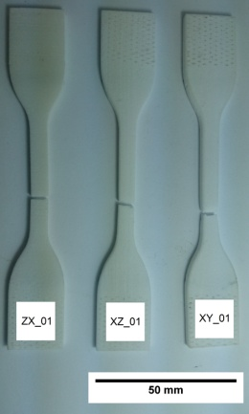

Figure 9. σ-ε curves of PA manufacture by SLS for each 3D printed orientation.

In the σ-ε curves of Figure 9 a more ductile behavior is observed in the XY and XZ orientations. On the other hand, the SPs manufactured in the ZX and ZY orientation presented a lower ductile behavior (approximately half the total deformation), consequently, presenting higher values of ultimate tensile strength, yield strength and elastic modulus. For Z orientations, the cross sectional area during laser scanning in the additive manufacturing process is smaller than another orientations, which may favor a local temperature increase and, consequently, an increase in the molar mass of the PA by the post-condensation reaction (Verbelen et al., 2016). This would explain the increase in the mentioned properties.

In general, the SPs manufactured in the ZX or ZY orientations had lower ductility, fracturing with little deformation.

1. Discussões

Falta discutir o que estes resultados representam em relação a funcionalidade. Acho que aqui seria importante relacionarmos, por exemplo a direção e a propriedade de tenacidade a fratura com o problema da funcionalidade marcha.

Em relação ao processo SLS:

* Os SPs apresentaram valores de tensão máxima maiores nas direções ZX e ZY;
* Os resultados de tensão de escoamento são homogêneos e repetitivos em todas as direções;
* Os resultados de módulo de elasticidade das direções de X e Y são similares;
* Os SPs possuem comportamento elástico praticamente idêntico;
* Os SPs nas direções XY e XZ apresentaram um comportamento dúctil, enquanto que os impressos na direção ZX apresentaram comportamento frágil;

1. Referências Bibliográficas

ASTM INT 52921-13 - Standard Terminology for Additive Manufacturing-Coordinate Systems and Test Methodologies. ASTM International, West Conshohocken, PA, 2013. Disponível em: <http://www.astm.org/Standards/E8.htm>.

ASTM F3091/F3091M-14 Standard Specification for Powder Bed Fusion of Plastic Materials, ASTM International, West Conshohocken, PA, 2014 Disponível em: <http://www.astm.org/Standards/E8.htm>.

ASTM INT D638. Standard Test Methods for Tension Testing of Metallic Materials 1. ASTM International, West Conshohocken, PA, 2009. Disponível em: <http://www.astm.org/Standards/E8.htm>.

COSTA-FÉLIX, R. P. B. Fundamentos da Metrologia e Avaliação da Conformidade METROLOGIA Conceitos básicos e fundamentais em Estatística Objetivos do Módulo • Apresentar os conceitos de Estatística Apresentação do GUM Estatística. [S.l.]: [s.n.], 2014. p. 1–19.

Engineering ToolBox, (2003). Young's Modulus - Tensile and Yield Strength for common Materials. [online] Available at: https://www.engineeringtoolbox.com/young-modulus-d\_417.html [Accessado em 20/06/2018].

Knoop F., Schoeppner V., Mechanical and thermal properties of FDM parts manufactured with polyamide 12, Proceeding of SFF symposium, Austin, TX, USA (2015), pp. 935-948

GABAUER, W. The Determination of Uncertainties in Tensile Testing; Voest-Alpine Stahl Linz GmbH: Linz, Austria, 2000.

INMETRO. GUM 2008 - Guia para a expressão de incerteza de medição. [S.l.]: [s.n.], 2008.

Leander Verbelen, Sasan Dadbakhsh, Michael Van den Eynde, Jean-Pierre Kruth, Bart Goderis, Peter Van Puyvelde, Characterization of polyamide powders for determination of laser sintering processability, European Polymer Journal, Volume 75, 2016, Pages 163-174.

SHACKELFORD, J. F.; ALEXANDER, W. (Ed.). CRC materials science and  
engineering handbook. 3rd ed. Boca Raton: CRC Press, 2001. 1928 p.

Starr, T. L., Gornet, T. J., Usher, John S., (2011) "The effect of process conditions on mechanical properties of laser‐sintered nylon", Rapid Prototyping Journal, Vol. 17 Issue: 6, pp.418-423